**Sim=Airbus A330-300**

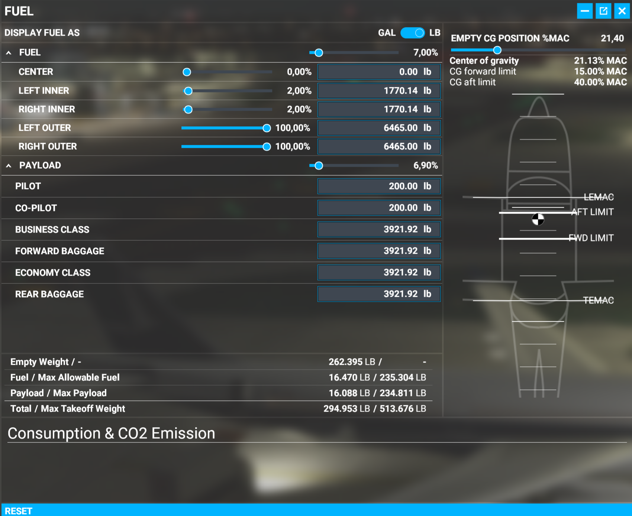

Fuel is CG neutral if filled in this Order:

1. Right+Left Outer
2. Right+Left Inner
3. Center

All Units in LB

**Fuel 25%:**

Tank.1=0

Tank.2=0.30869764089584350586

Tank.3=0.30869764089584350586

Tank.4=1

Tank.5=1

|  |  |  |  |  |  |  |  |  |
| --- | --- | --- | --- | --- | --- | --- | --- | --- |
| **Payload** | | **Fuel** | | **CG** | **Comment** | **Tanks** | | |
| ***LB*** | ***%*** | ***LB*** | ***%*** | ***%*** |  | ***2xOUT*** | ***2xINR*** | ***CTR*** |
| **48200** | 25% | 58826 | 25% | 21,86% |  | 100% | 31% | 0% |
| 98,5% | 202361 | 86% | 21,10% | Max Fuel | 100% | 100% | 55% |

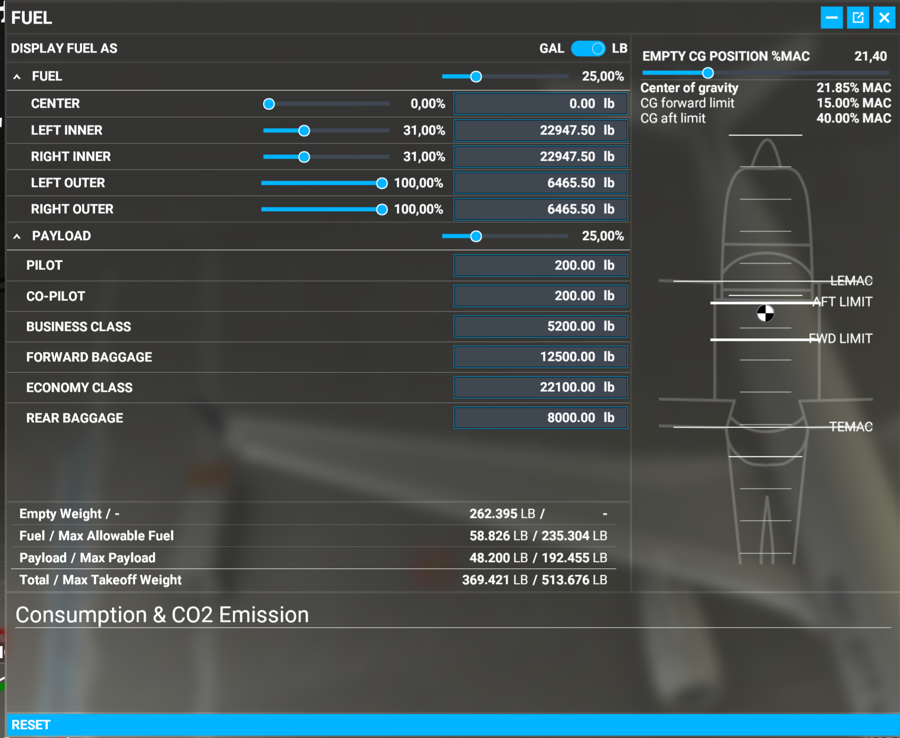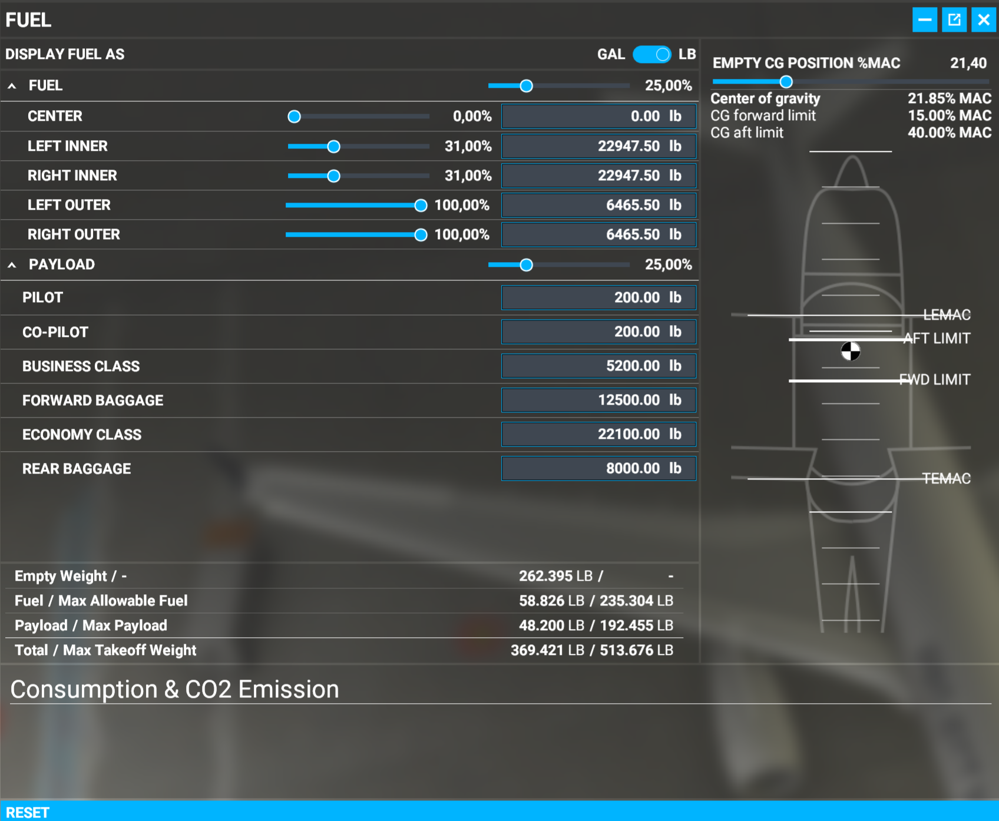

PayloadList= 200.0, 200.0,5200.0,12500.0,22100.0,8000.0

|  |  |  |  |  |  |  |  |  |
| --- | --- | --- | --- | --- | --- | --- | --- | --- |
| **Payload** | | **Fuel** | | **CG** | **Comment** | **Tanks** | | |
| ***LB*** | ***%*** | ***LB*** | ***%*** | ***%*** |  | ***2xOUT*** | ***2xINR*** | ***CTR*** |
| **96200** | 50% | 58826 | 25% | 21,86% |  | 100% | 31% | 0% |
| 97,8% | 152948 | 65% | 21,78% | Max Fuel | 100% | 94% | 0% |

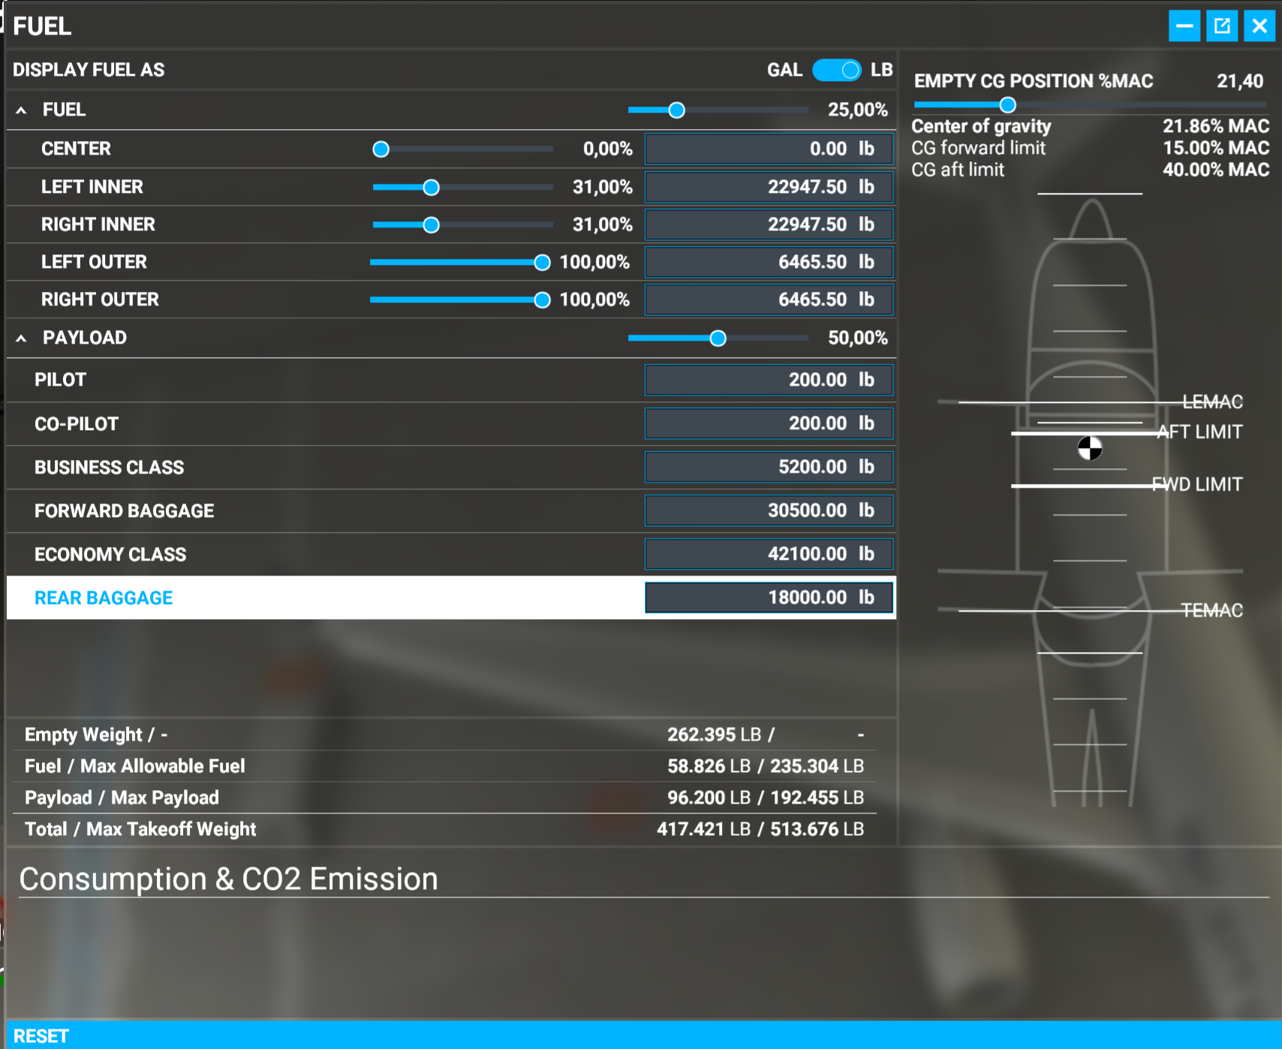 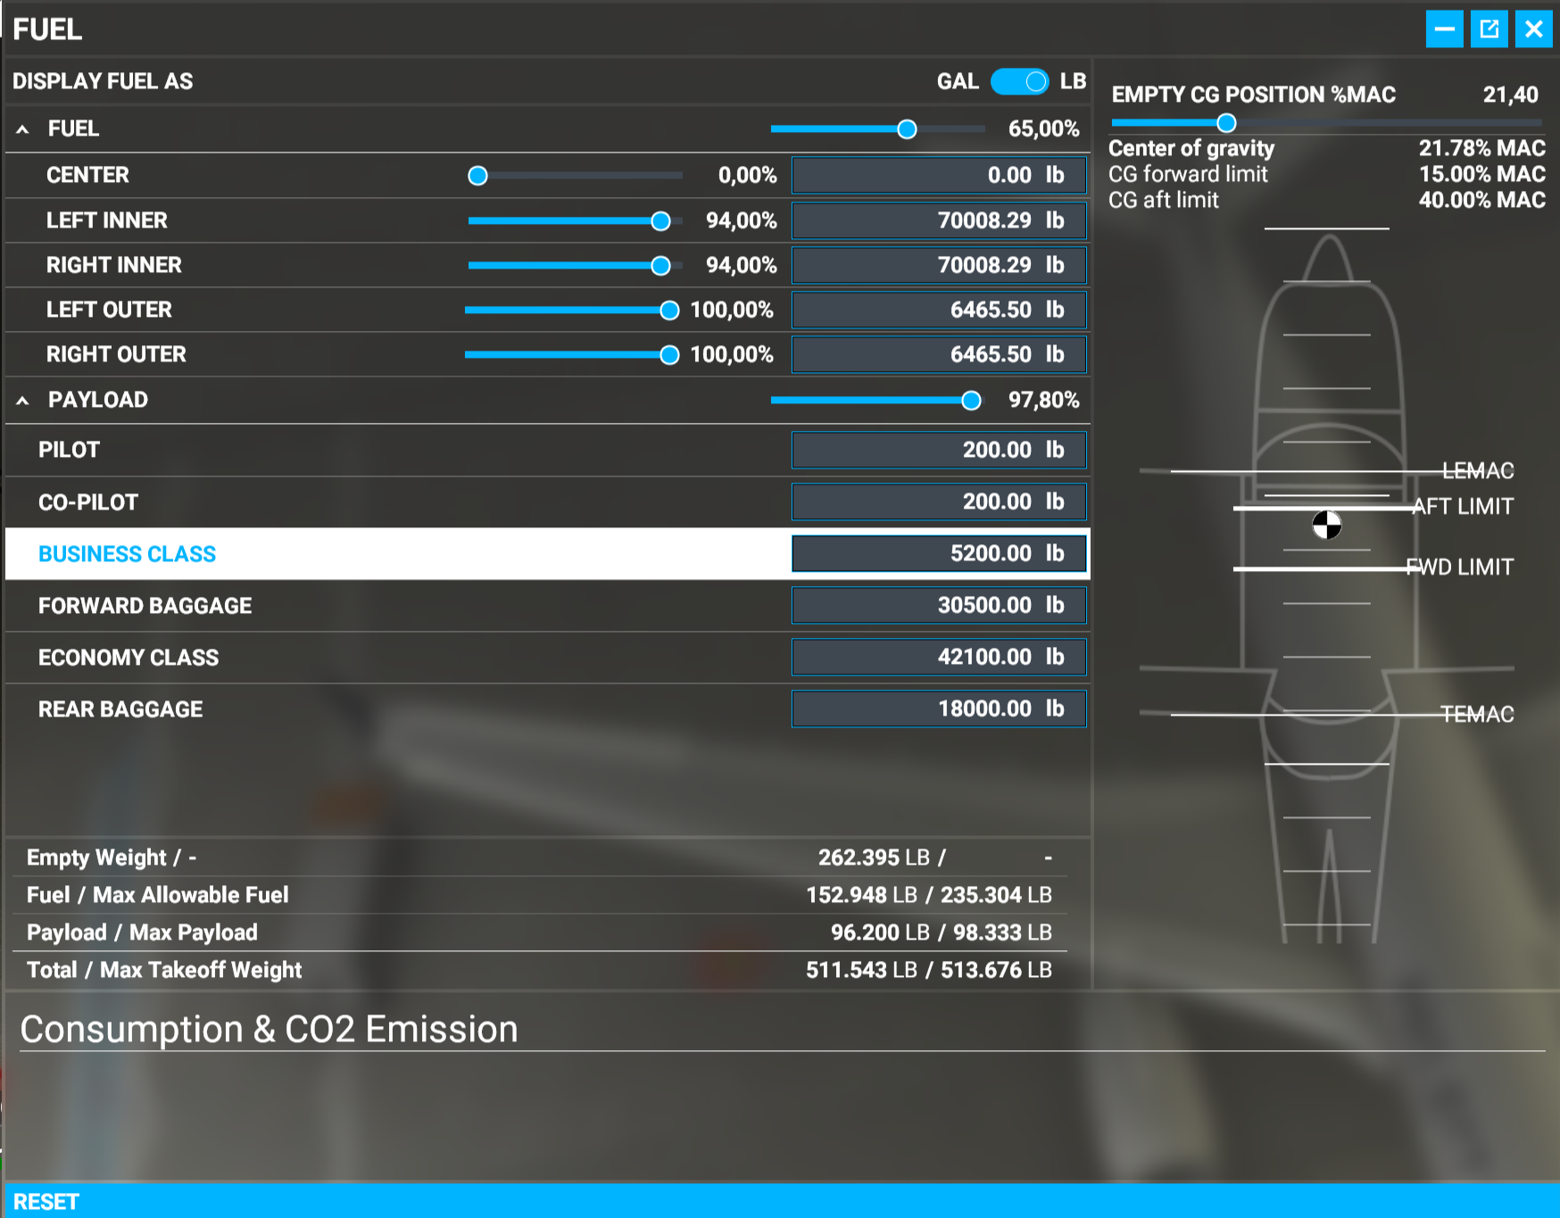

PayloadList= 200.0, 200.0,5200.0,30500.0,42100.0,18000.0

|  |  |  |  |  |  |  |  |  |
| --- | --- | --- | --- | --- | --- | --- | --- | --- |
| **Payload** | | **Fuel** | | **CG** | **Comment** | **Tanks** | | |
| ***LB*** | ***%*** | ***LB*** | ***%*** | ***%*** |  | ***2xOUT*** | ***2xINR*** | ***CTR*** |
| **173200** | 90% | 58826 | 25% | 21,82% |  | 100% | 31% | 0% |
| 97,8% | 77650 | 33% | 21,81% | Max Fuel | 100% | 44% | 0% |

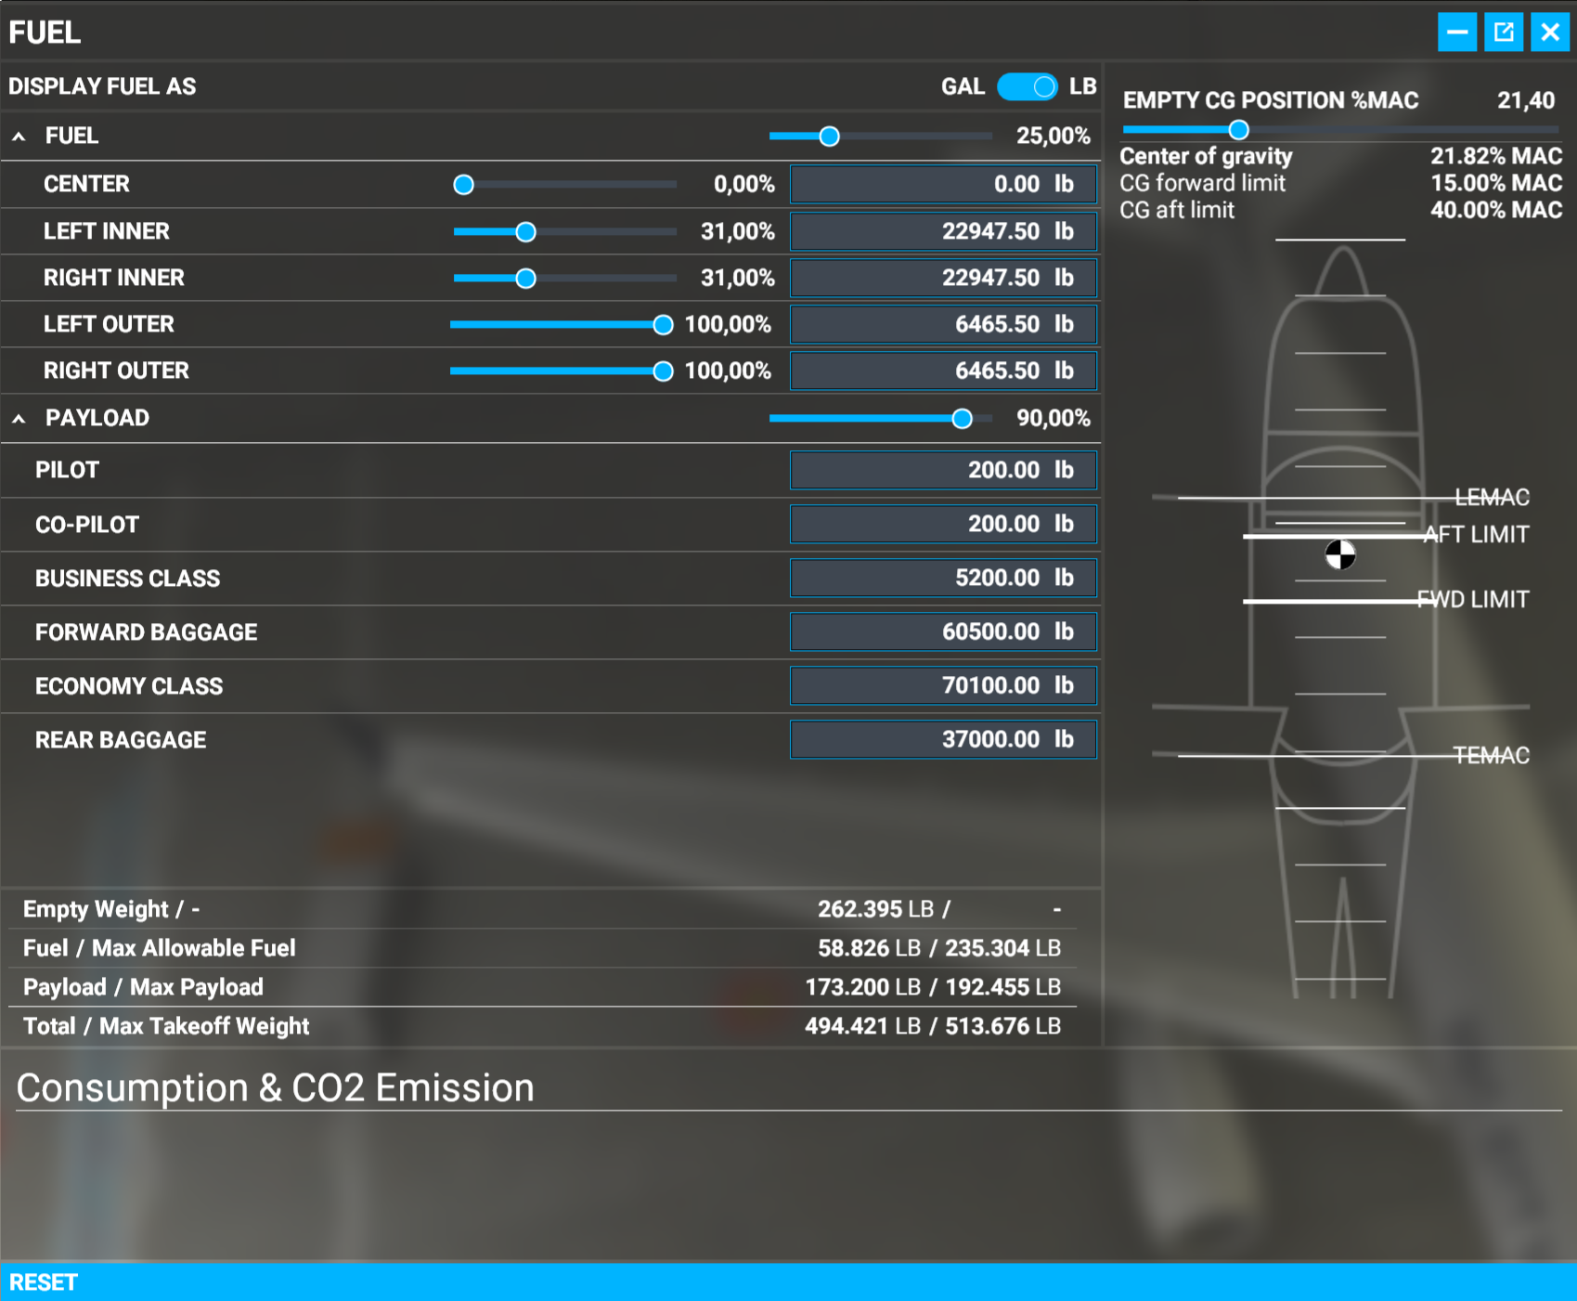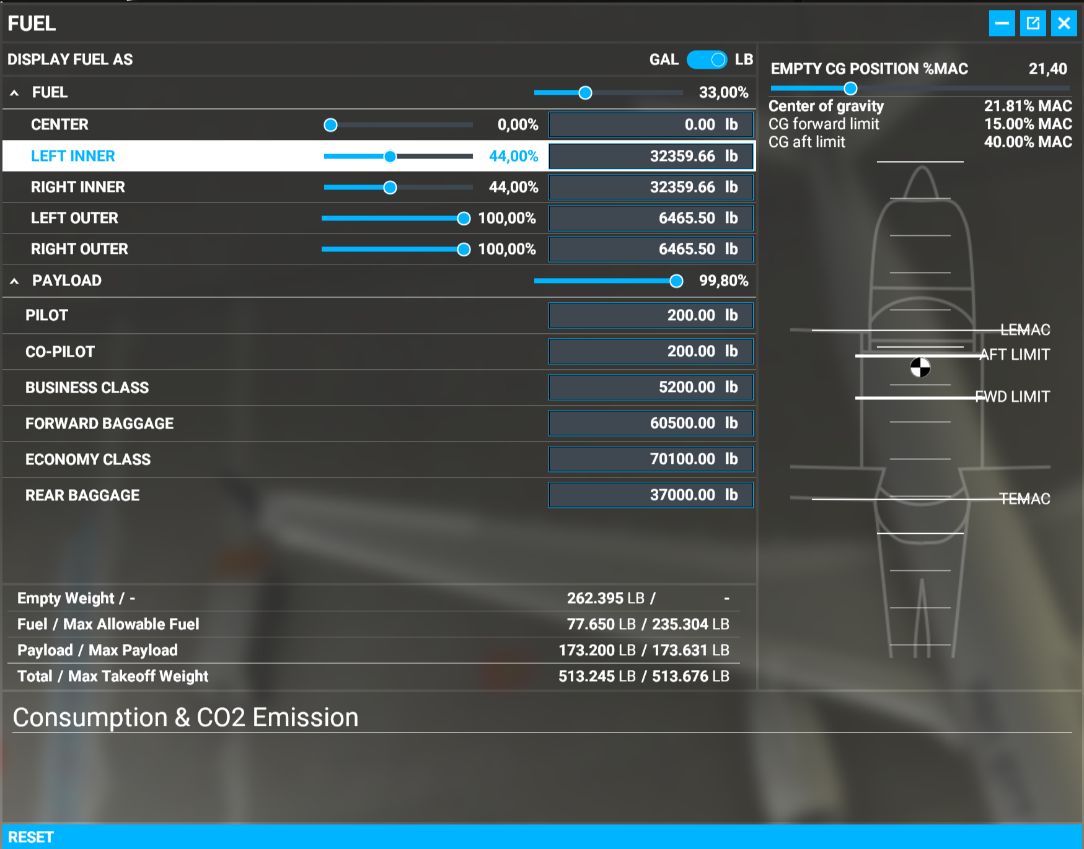

PayloadList= 200.0, 200.0,5200.0,60500.0,70100.0,37000.0